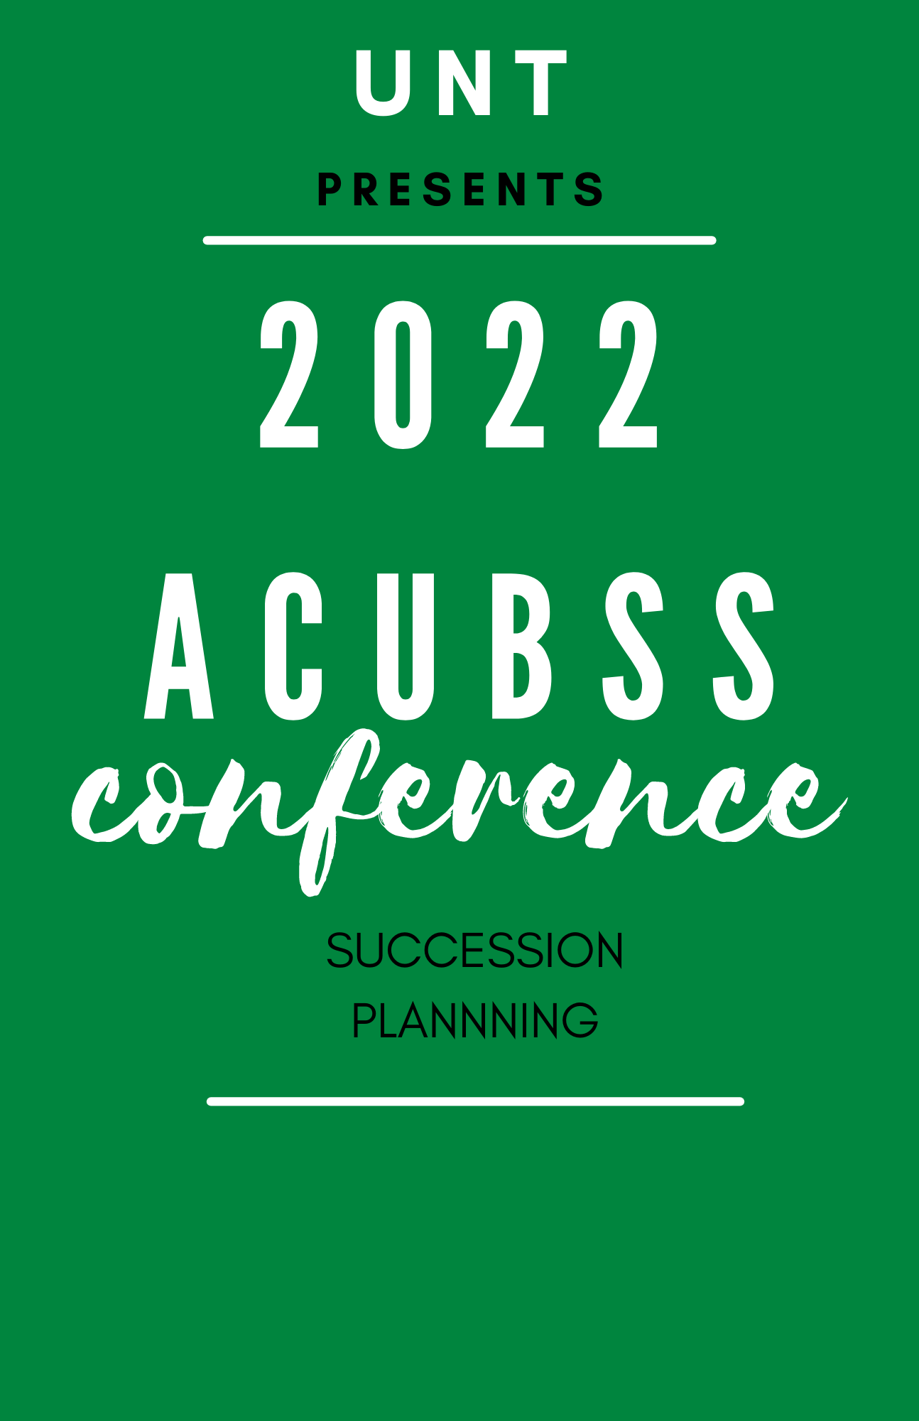

NOVEMBER 1-3

UNIVERSITY OF NORTH TEXAS
GATEWAY CENTER

SCHEDULE
Monday 10/31
5:00 pm – 6:00 pm | Executive Board Meeting
6:00 pm – 7:00 pm | Meet & Greet | Welcome Center, 1417 Maple Street
Tuesday11/1
9:00 am –12:00pm | Tours: Joe Greene Hall  Bruzzy’s Golf Facility  Mean Green Practice Facility  BLB  Lunch (on your own)  Activities on your own
 | Conclusion of Day 1
Wednesday 11/2 | Gateway Center
8:00 am – 8:15 am | Welcome & Introductions: ACUBSS President
8:15 am – 8:30 am | Opening Remarks: Danny Armitage, Associate VP for Auxiliary Services
8:30 am – 10:30 am | Keynote Speaker Jim Round-Rounded Development
10:30 am – 11:00 am | Short Break | Exhibitor Showcase
11:00 am – 12:00 pm | Guest Speaker: Paul Ballard (Unger Enterprises)
12:00 pm – 1:00 pm | Lunch
1:00 pm – 1:15 pm | Raffle Drawing
1:15 pm – 2:00 pm | Guest Speaker: David DeMattia – Restoration Specialists
3:00 pm – 3:30 pm | Short Break | Exhibitor Showcase
3:30 pm – 4:30 pm | Guest Speaker: Norm Sobecki +Josh Crane(Envirox)  4:30pm-5:00pm Exhibitor Showcase
5:00 pm | Conclusion of Day 2
6:00pm-8:00pm | Dinner with entertainment Gateway Room 54
Thursday 11/3
8:00 am – 10:00 am | Guest Speaker: Jerri Robertson –UNT Business Ops training
10:00 am – 10:15 am | Short Break
10:20 am – 11:00 am | Executive Board Elections & Group Photo
11:15 am – 11:45 am | Lunch, Closing Remarks, & Adjournment
12:00 pm | End of Conference
12:00 pm – 1:00 pm | Executive Board Meeting

